**Unzip the file to a temp folder.**

To update your version to the new 6.0 you must:

1. Copy the files in the main directory to the Simsol program folder, usually C:\Simsol\Desktop.
2. Copy the files and subfolders in DATA folder to the Simsol data folder, usually c:\Simsol\Desktop\Data.

**Start Simsol**Simsol will go through an update process.

Goto Maintain TAB – click on Preferences

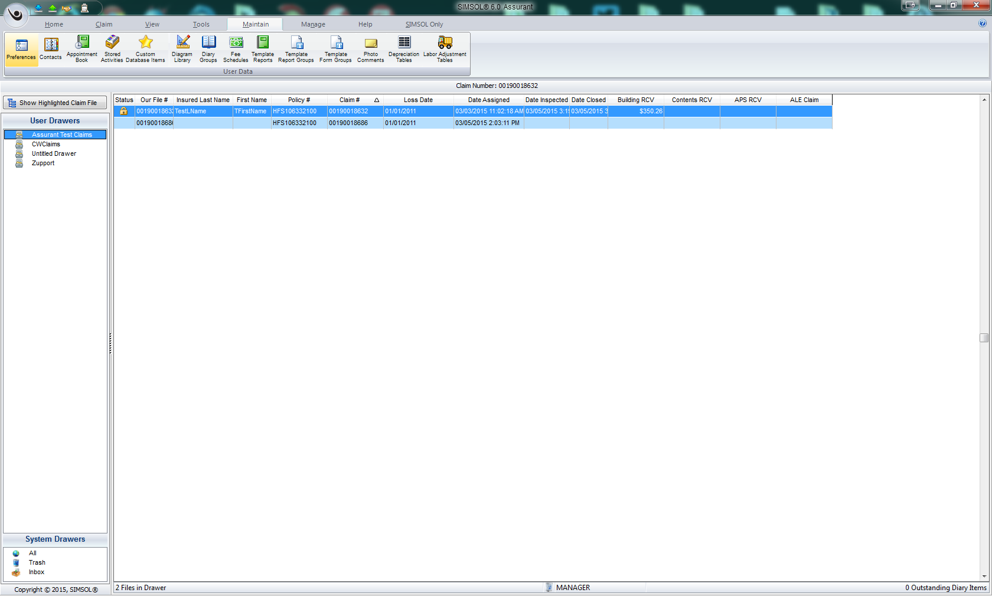

**On the left, select “Claimswire”**

Uncheck the “Show Claimswire information on Main Screen”  
Enter 30 for “Status Reports due every XXX days”  
Enter username, password, and for testing in the URL enter: <https://dev.simsol.com>

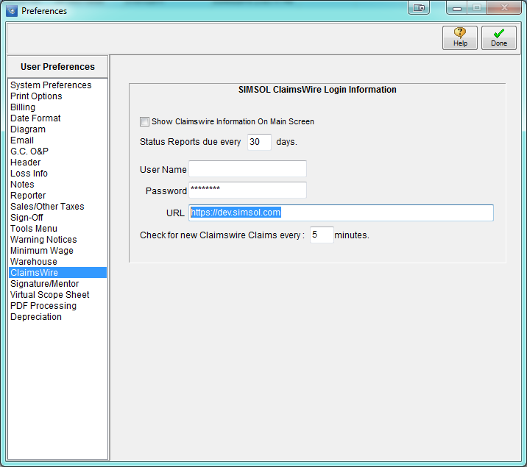

Click Done

Exit and restart Simsol.

When you restart you should see a new Tray icon utility in the lower right. Looks like a little globe.

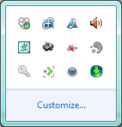

If you right click on the globe you will get a set of menus…

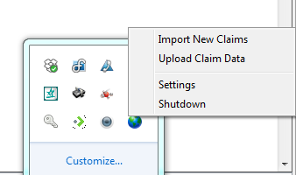

The user should not have to use these, however, they are provided for support purposes.

When the tray icon starts up, it checks for any milestones that need to be uploaded. Any documents that need to be uploaded, and any claims from ICE that need to be downloaded.

If there are claims to download, it will automatically download them, and place them in the SIMSOL INBOX. The icon for the utility will change to a set of eyes and give the user a notification that new claims are available.

Once new claims are available in the INBOX, the user must move the claim to a valid drawer.

Select the file and drag and drop it to a drawer.

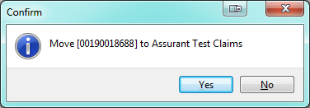

You should see the claim moved to a drawer.

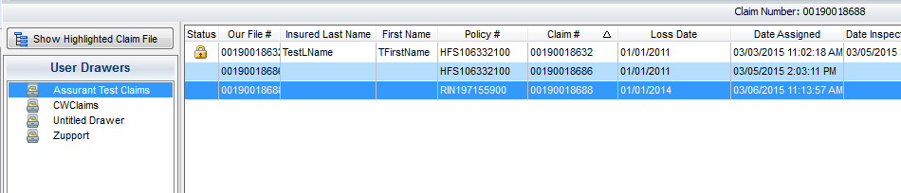

You can now double click on the claim to open it. And you should see the loss information.

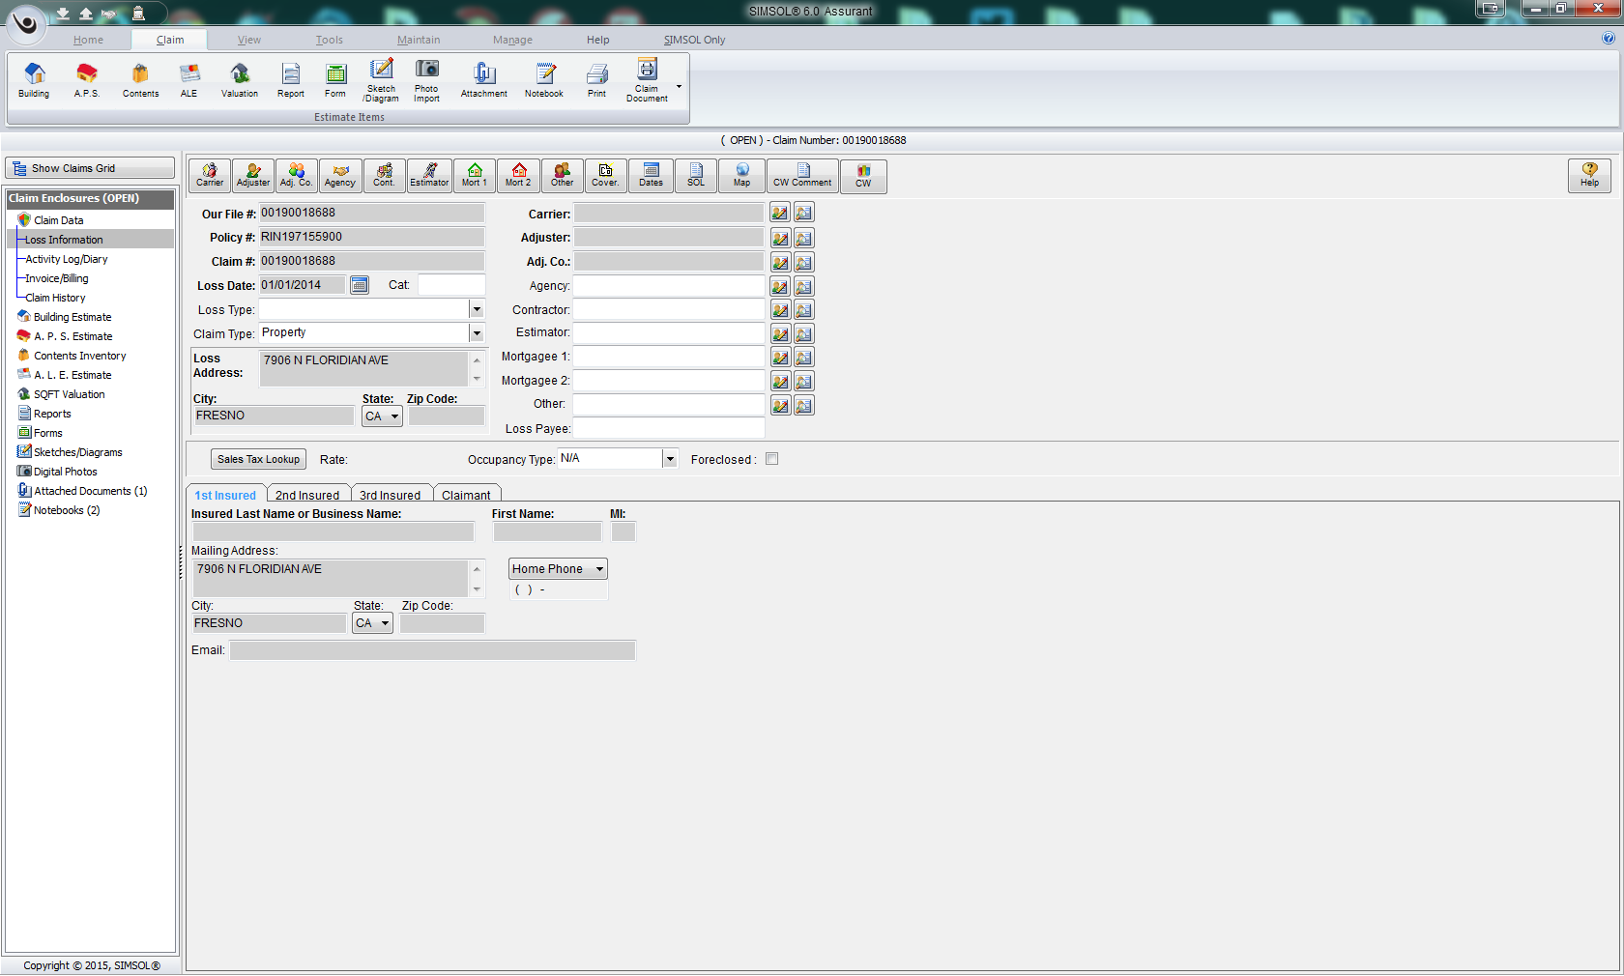

Click on the coverages button to review the coverage info

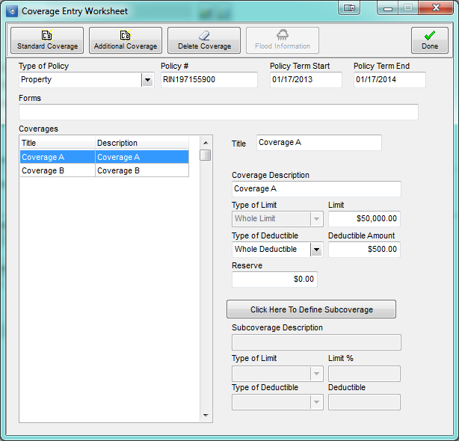

Close the coverages, and click on the DATES button

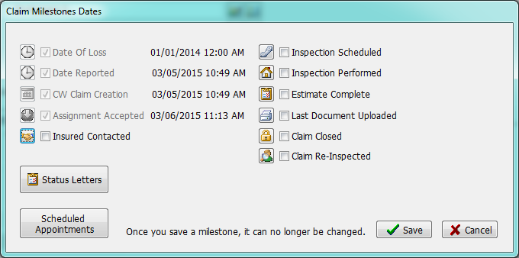

Click the STATUS LETTERS button to enter status report dates.

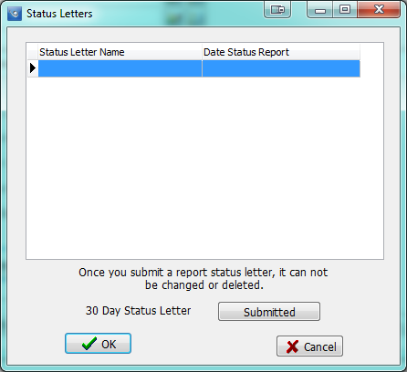

Here you can click on any milestone, click save, and it will populate a database and send a message to the tray icon utility to automatically upload it to Claimswire.

On the loss info screen click the CW Comment button to enter Claimswire comments

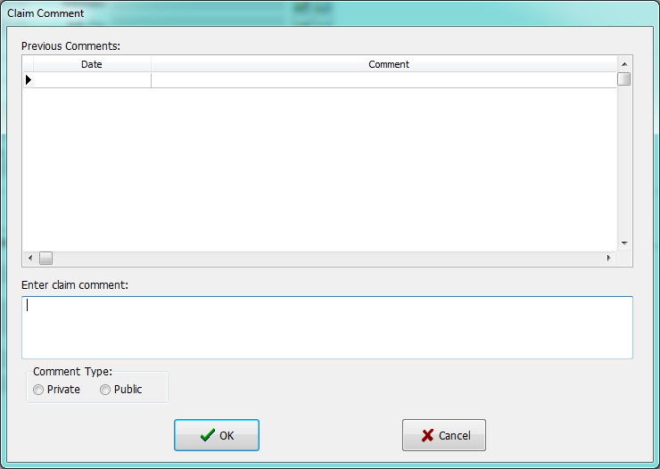

Enter comments on the bottom, select public/private, and click ok to send the comment to CW.

**On the main screen, on the left, click NOTEBOOKS**

You should see two notebooks, one for additional Claim information, the other for the ICE coverage data

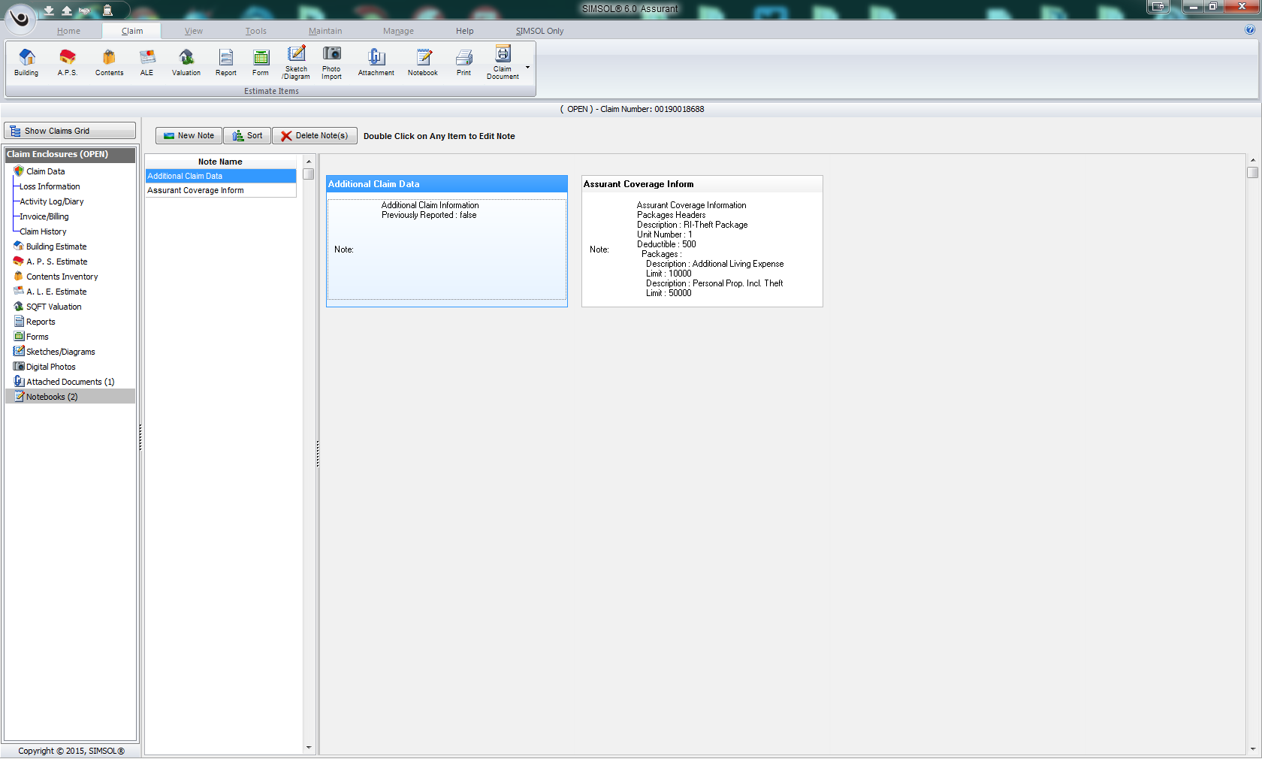

If you double click on the “Assurant Coverage Information”, you’ll see the coverage info.

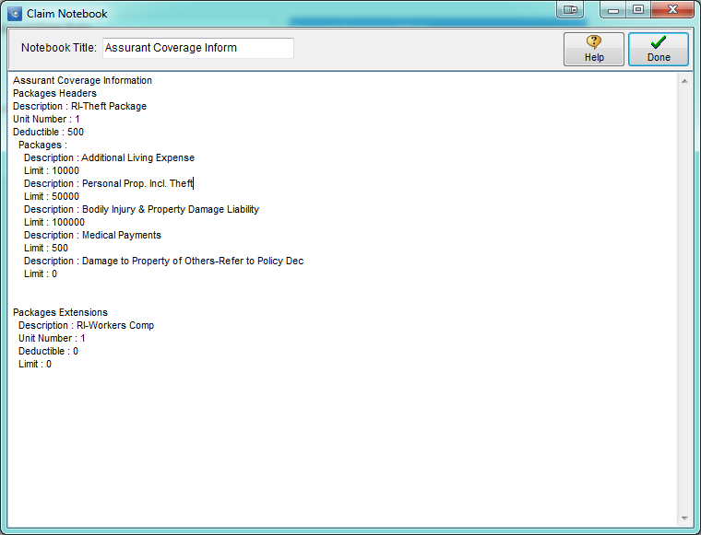

Create several estimates, photos, etc. and go to the loss information Dates button. Click close claim, then save, and the system will automatically begin building the PDF printouts, posting them to a database, and sending a message to the tray icon to start uploading them to Claimswire. The print process works just like the current Assurant upload print process.

**Some Items I’m working on:**

1. **When Simsol starts having a dialog display which Status reports are over-due or near due date.**
2. **Need to verify that no two estimates have the same name**
3. **On the master print screen, there is a Kwikworks button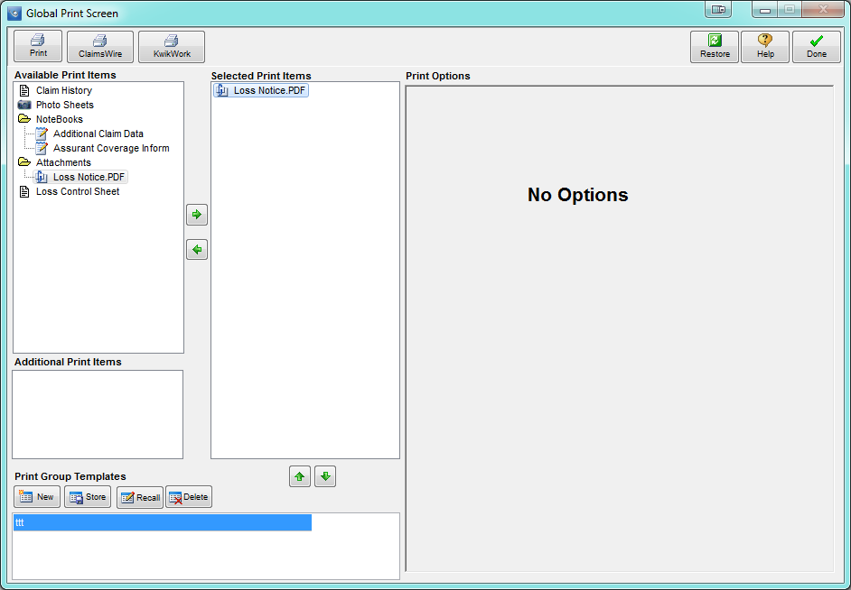It lets the users pick any estimate section item and print it, and automatically upload it to CW.  
   I have to only allow the user to have one print item to upload at a time because they have to pick the doc/subdoc type. Let me know if this is OK.  
     
   This will allow the user to upload any estimate item or document to Claimswire before the claim is closed.**